Overview
The trading_rules package provides a lightweight, object-oriented framework for implementing rule-based trading logic. Each rule is defined as a class that inspects market data and the current position state, returning a concise trading signal—BUY, HOLD, SELL, or NONE.
Design Principles
- Object-oriented: each rule is represented as a class inheriting from a shared base (TradingRule). This makes rules easy to reason about, test, and extend.

- Minimal surface area: rules receive only the data they need (MarketData, Positions) and return a TradingSignalEnum value. They do not execute trades or mutate shared state.

- Deterministic and side-effect free: generate_signal implementations should rely solely on their inputs and must not modify internal or external state.

- Composable: an external strategy or rule engine can instantiate multiple rules and aggregate their outputs, enabling flexible orchestration and layering of decision logic.

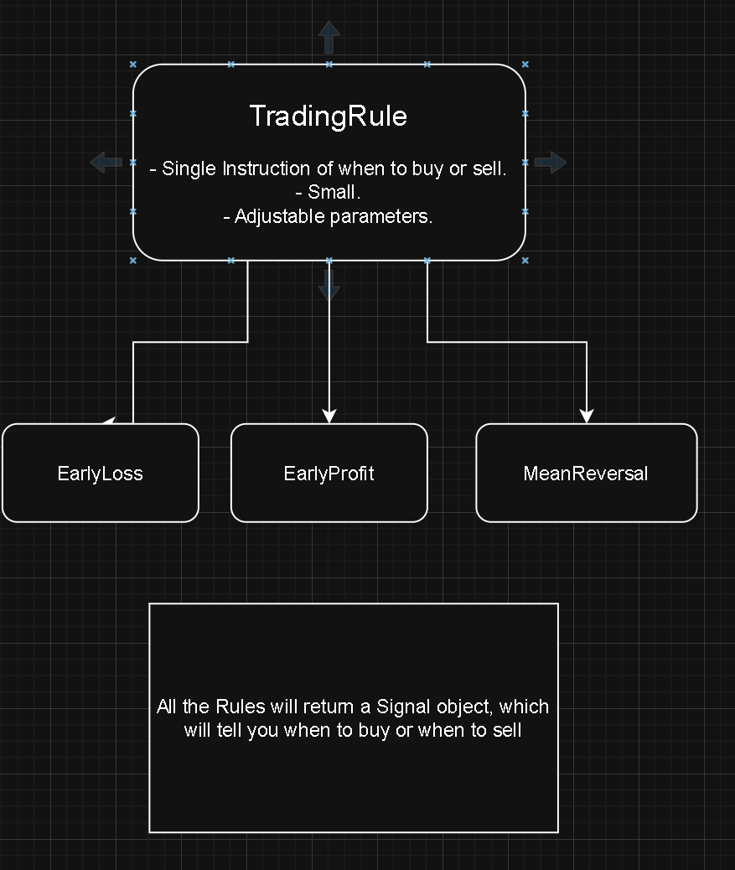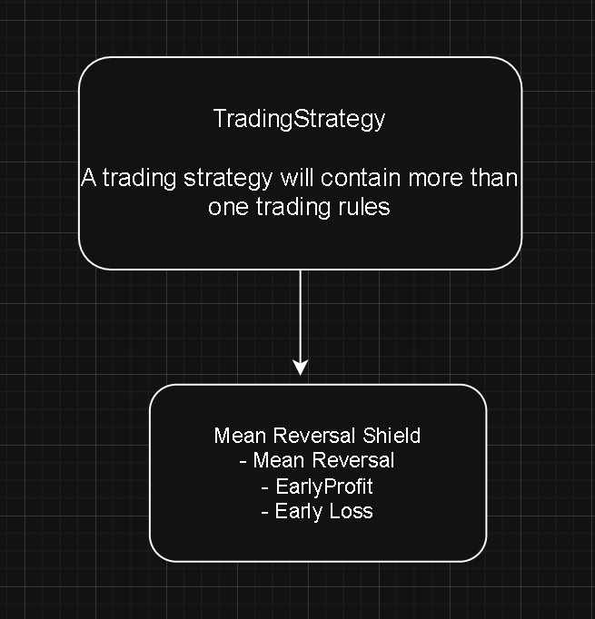
Core Components
- TradingRule (abstract base class):
Defines the contract generate_signal(self, market_data, positions_data) -> TradingSignalEnum.
- MarketData:
A convenience wrapper around a Pandas DataFrame of prices. Provides helper methods such as get_latest_price() and get_mean(window).
- Positions / PositionData:
Light-weight objects describing open positions. Common methods include are_we_holding_positions() and get_entry_price().
- signals:
Contains TradingSignalEnum (BUY, HOLD, SELL, NONE) and a TradingSignal wrapper for attaching metadata such as rule name, confidence, or justification.
Example Rules
- EarlyProfitTaker:
Emits a SELL signal when unrealized profit on an open position exceeds a configured threshold.
- EarlyLossTaker:
Emits a SELL signal when unrealized losses exceed a configured threshold.
- MeanReversal:
Issues a BUY signal when a short-term moving average drops below a long-term moving average (a simple mean-reversion heuristic).

Implementation Notes
The current implementation assumes a single active position for the included sample rules.
To support multiple positions, rules should iterate over the Positions.positions collection or the project should clearly define whether rules operate under single- or multi-position semantics.
Extensibility
To add a new trading rule:
- Create a new module under trading_rules/.
- Subclass TradingRule and implement
generate_signal(self, market_data, positions_data).
- Keep the logic deterministic and side-effect free.
- Use the logging module for observability and debugging.

